 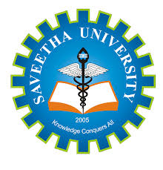

**CAPSTONE PROJECT REPORT**

**PROJECT TITLE**

THE EVOLUTION OF SOFTWARE DEVELOPMENT METHODOLOGIES:

FROM WATERFALL TO AGILE

**REPORT SUBMITTED BY:**

**S. Monesh**

**COURSE CODE**: CSA1087

**COURSE NAME:** Software Engineering for Web Development.

**ABSTRACT:**

The evolution of software development methodologies has significantly shaped the software industry, transitioning from traditional Waterfall models to modern Agile practices. This project explores the historical development, key principles, and applications of these methodologies, focusing on their role in addressing project challenges. By comparing their processes through a practical example—a calculator application—this study highlights the methodologies' impacts on efficiency, flexibility, and collaboration. The project also delves into the development lifecycle, from requirements gathering to deployment and maintenance, demonstrating their real-world implications.

**Introduction:**

The evolution of software development methodologies has been pivotal in shaping how software is designed, developed, and delivered. Traditional methodologies like the Waterfall model provided structure and predictability but struggled with flexibility in responding to changing requirements. This led to the emergence of Agile methodologies, which prioritize adaptability, collaboration, and continuous delivery. The shift from Waterfall to Agile reflects the industry's growing need for faster and more efficient ways to meet customer demands and manage complex projects.

**Background:**

**1.Waterfall Methodology**:

* Introduced in 1970.
* Linear, phase-based approach.
* Focus on upfront planning and documentation.

2.**Agile Methodology**:

* Manifested in 2001 with the Agile Manifesto.
* Iterative, flexible approach.
* Emphasis on collaboration and customer feedback.
* The late 1990s and early 2000s saw the rise of Agile methodologies, formalized in the Agile Manifesto in 2001. Agile iterative and incremental approach addressed the need for flexibility and customer involvement, enabling faster delivery and

**3.The Shift**:

* Increasing project complexities demanded more adaptable methods.
* Agile addresses the limitations of Waterfall through iterative workflows.

**Objectives:**

The main objectives of this study on "The Evolution of Software Development Methodologies: From Waterfall to Agile" are:

1. **To analyze the historical development** of software methodologies and their impact on the software industry.
2. **To compare and contrast** the principles, processes, and outcomes of Waterfall and Agile methodologies.
3. **To demonstrate the practical application** of both methodologies through real-world examples and coding demonstrations.
4. **To evaluate the advantages, challenges, and modern-day applications** of Agile methodologies in a rapidly evolving industry.
5. **To provide insights into future trends** and the continuous evolution of software development practices.

**Requirements Gathering:**

**Functional Requirements:**

* The calculator should support addition, subtraction, multiplication, and division.
* Inputs are taken via the console.

**Non-Functional Requirements:**

* The system should be robust against invalid inputs.
* Ensure efficient computation within milliseconds.

**Historical Context:**

1. **Pre-Methodology Era**:
   * Early approaches were ad hoc and lacked standardization.
   * Projects often failed due to unclear requirements and disorganized processes.
2. **The Waterfall Model**:
   * **Origin**: Proposed by Winston W. Royce in 1970.
   * **Key Features**:
     + Sequential phases: Requirements → Design → Implementation → Verification → Maintenance.
     + Emphasis on documentation and upfront planning.
   * **Challenges**:
     + Inflexibility to change.
     + Late feedback loops.
     + Misalignment with evolving customer needs.

**Agile Methodology: A Modern Approach to Software Development**

Agile methodology is a dynamic, iterative approach to software development and project management that emphasizes collaboration, flexibility, and delivering value incrementally. Unlike traditional methodologies like Waterfall, Agile allows teams to respond quickly to changes, ensuring that the product aligns with evolving customer needs and market conditions.

**Core Concepts of Agile Methodology**

1. **Iterative Development**:  
   Agile divides the project into small, manageable increments called iterations or sprints. Each iteration results in a potentially shippable product increment.
2. **Collaborative Work Environment**:  
   Agile promotes teamwork and open communication among developers, product owners, and stakeholders. Daily standups and sprint reviews ensure alignment and transparency.
3. **Customer Feedback**:  
   Customers are involved throughout the development cycle, providing feedback at regular intervals, which helps refine the product.
4. **Continuous Improvement**:  
   Teams conduct retrospectives at the end of each sprint to reflect on what went well and what could be improved, fostering an environment of learning and growth.

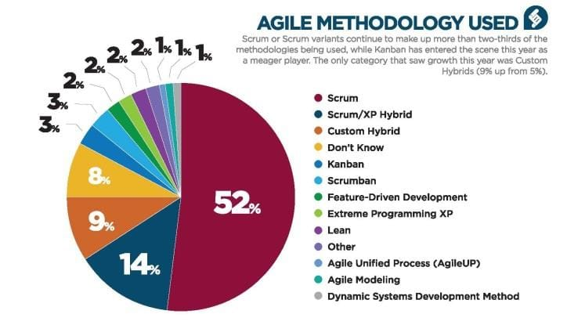

**The Agile Revolution:**

1. **Manifestation of Agile (2001)**:
   * Birthplace: Snowbird, Utah, USA.
   * Agile Manifesto Principles:
     + Individuals and interactions over processes and tools.
     + Working software over comprehensive documentation.
     + Customer collaboration over contract negotiation.
     + Responding to change over following a plan.
2. **Popular Agile Frameworks**:

* + **Scrum**:
    - Defined roles (Product Owner, Scrum Master, Team).
    - Time-boxed sprints with iterative goals.
  + **Crystal**:

Crystal is a family of methodologies (e.g., Crystal Clear, Crystal

Orange) that vary based on team size, project criticality,

and system complexity. It emphasizes communication

aptability.

* + **Kanban**:
    - Visual workflow representation for continuous improvement.
  + **Extreme Programming (XP)**:
    - Practices like pair programming, continuous integration, and frequent releases.
  + **Dynamic Systems Development Method (DSDM):**
* DSDM is an iterative and incremental approach designed for rapid application development. It provides a robust framework for project management and delivery.
  + **Feature-Driven Development (FDD):**
* FDD is a model-driven methodology focused on delivering features incrementally. It combines the best practices of other Agile methods, such as iterative development and domain modeling.

**Waterfall Methodology: A Traditional Approach to Software Development**

The Waterfall methodology is a sequential and linear approach to software development and project management. Developed in the 1970s, it emphasizes thorough planning and documentation, with each phase of the project completed before moving to the next. Waterfall is ideal for projects with clearly defined requirements and minimal expected changes.

**Core Concepts of Waterfall Methodology**

1. **Sequential Phases**:  
   The project is divided into distinct stages that follow a strict order:
   * Requirements Gathering
   * System Design
   * Implementation (Coding)
   * Testing
   * Deployment
   * Maintenance
2. **One-Way Progression**:  
   Each phase must be completed before the next begins, with little to no overlap or revisiting of prior stages.
3. **Thorough Documentation**:  
   Detailed documentation is created at every stage, serving as a blueprint for the project.
4. **Limited Flexibility**:  
   Changes to requirements or designs are difficult to accommodate once the project progresses past the early stages.

**Comparative Analysis: Waterfall vs. Agile**

| **Feature** |  | **Waterfall** | **Agile** |
| --- | --- | --- | --- |
| **Flexibility** |  | Low | High |
| **Customer Involvement** |  | Minimal | Continuous |
| **Risk Management** |  | Reactive | Proactive |
| **Delivery Cycle** |  | Long | Short, iterative |
| **Documentation** |  | Extensive | Lightweight |
|  |  |  |  |

**Code Example: A Simple Agile Task Tracker**

**1. Create an index.html file:**

html

Copy code

<!DOCTYPE html>

<html lang="en">

<head>

<meta charset="UTF-8">

<meta name="viewport" content="width=device-width, initial-scale=1.0">

<title>Agile Task Tracker</title>

<link rel="stylesheet" href="styles.css">

</head>

<body>

<h1>Agile Task Tracker</h1>

<div id="task-container">

<input type="text" id="task-input" placeholder="Add a task..." />

<button onclick="addTask()">Add Task</button>

<ul id="task-list"></ul>

</div>

<script src="script.js"></script>

</body>

</html>

2. Create a styles.css file (optional for styling):

css

Copy code

body {

font-family: Arial, sans-serif;

text-align: center;

margin: 20px;

}

#task-container {

max-width: 400px;

margin: 0 auto;

}

#task-input {

width: 70%;

padding: 10px;

margin-bottom: 10px;

}

button {

padding: 10px 20px;

cursor: pointer;

background-color: #0078d7;

color: white;

border: none;

border-radius: 5px;

}

ul {

list-style-type: none;

padding: 0;

}

li {

margin: 5px 0;

padding: 10px;

border: 1px solid #ccc;

border-radius: 5px;

display: flex;

justify-content: space-between;

align-items: center;

}

li button {

background-color: red;

color: white;

border: none;

border-radius: 5px;

padding: 5px 10px;

cursor: pointer;

}

3. Create a script.js file:

javascript

Copy code

// Function to add a task to the list

function addTask() {

const taskInput = document.getElementById("task-input");

const taskList = document.getElementById("task-list");

if (taskInput.value.trim() === "") {

alert("Task cannot be empty!");

return;

}

const li = document.createElement("li");

li.textContent = taskInput.value;

const removeButton = document.createElement("button");

removeButton.textContent = "Remove";

removeButton.onclick = function () {

taskList.removeChild(li);

};

li.appendChild(removeButton);

taskList.appendChild(li);

taskInput.value = "";

}\

**Index.html**

**Style.css**

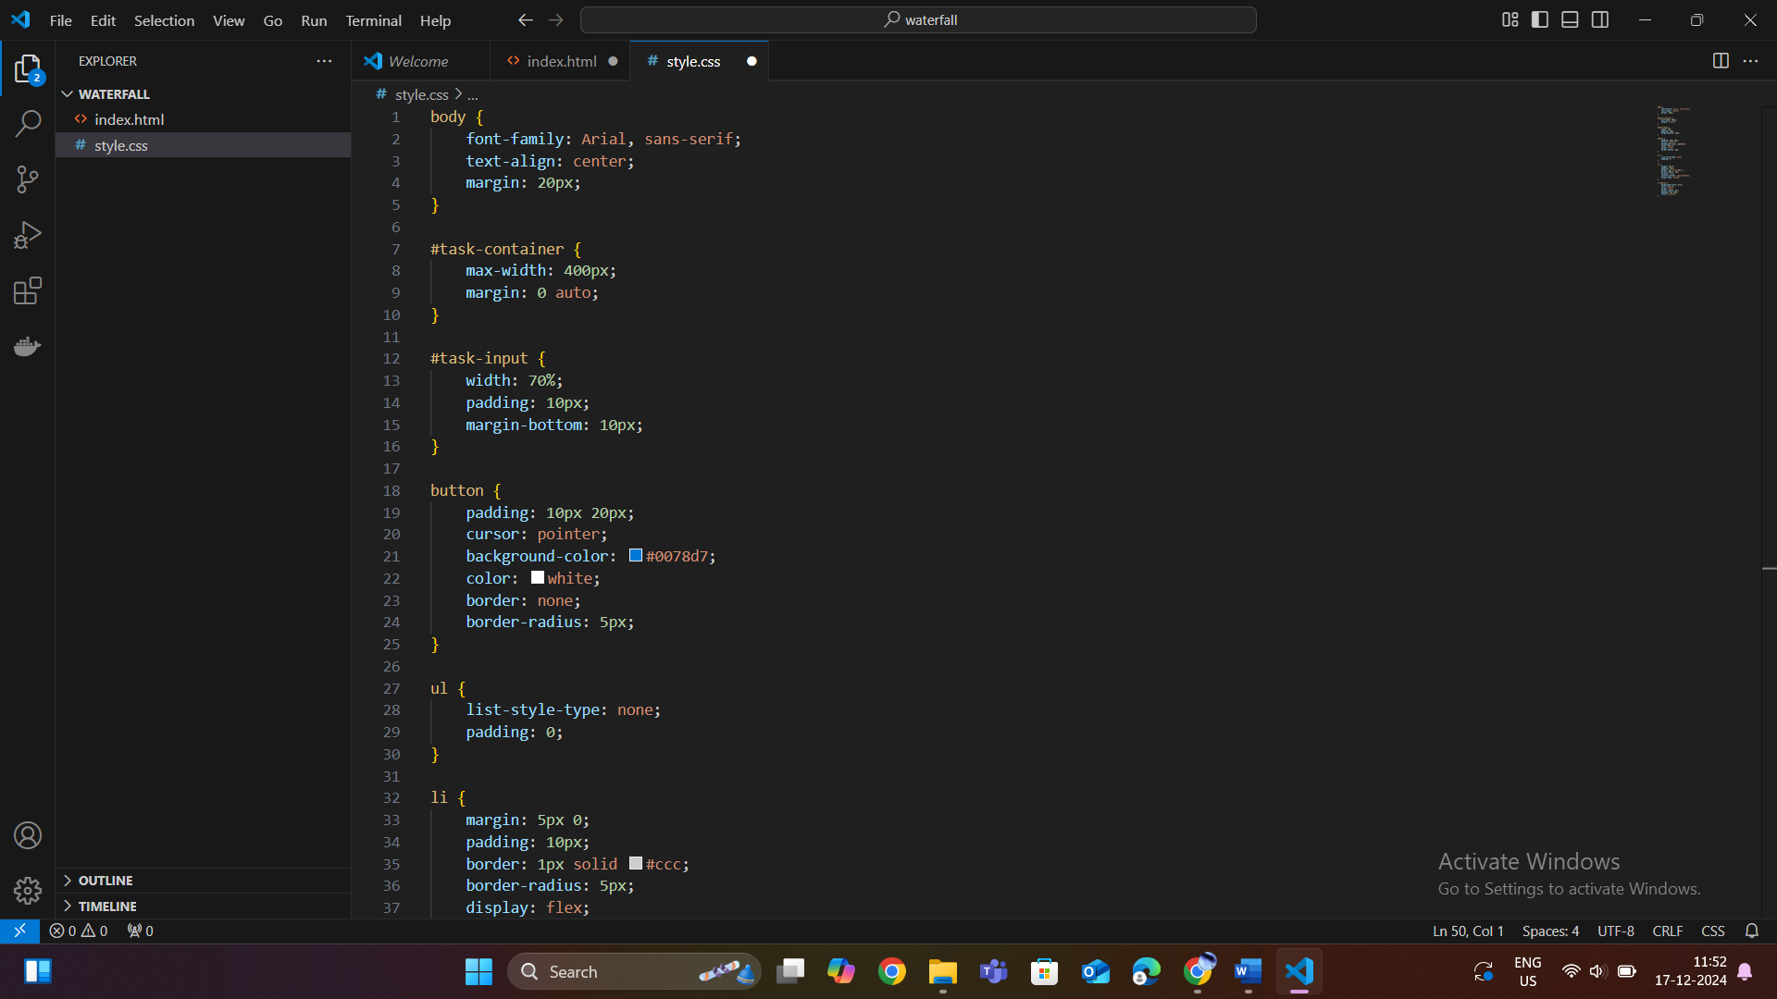

**Script.js**

**OUTPUT:**

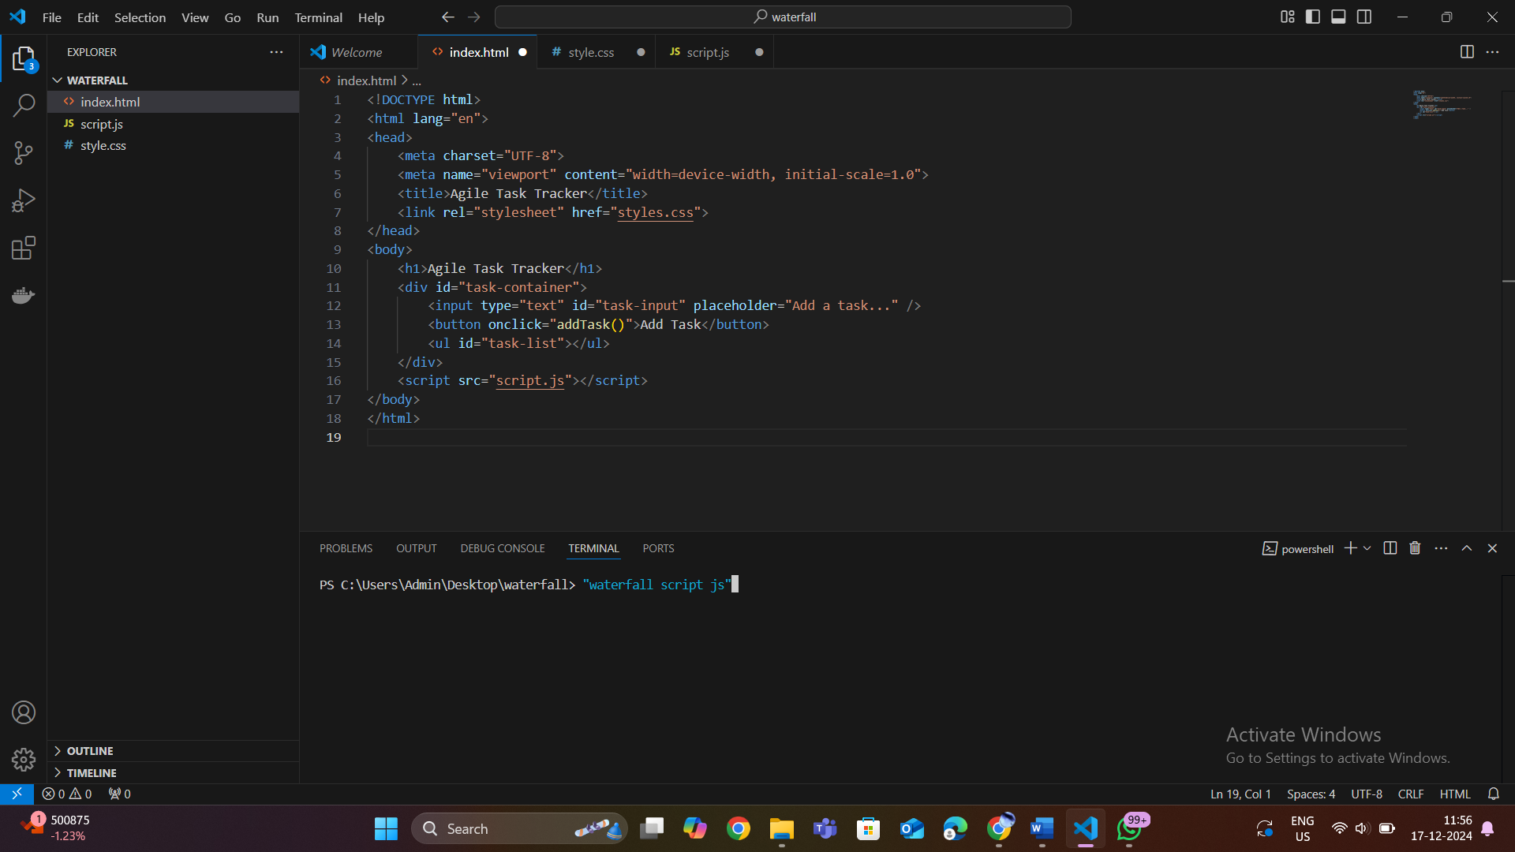**e**

**TRANSITION TO AGILE FROM WATERFALL:**

* MICROSOFT
* IBM
* NASA
* CISCO
* NOKIA
* HP (Hewlett-Packard)

**1.Microsoft**

* Past:
  + Microsoft historically used the Waterfall model to develop early versions of software like Windows and Office. This approach suited large-scale, sequential projects where requirements were well-defined.
  + For example, the development of Windows XP followed the Waterfall model, involving long development cycles with extensive documentation and rigid testing phases.
* Transition to Agile:
  + Faced with increasing competition from more dynamic companies and the need for faster delivery, Microsoft adopted Agile for projects like Azure and later versions of Windows and Office (e.g., Office 365).
* Current Practices:
  + Microsoft now uses Scrum and Kanban extensively across teams to develop software iteratively and deliver continuous improvements.

**2. IBM**

* Past:
  + IBM relied heavily on Waterfall for developing complex systems, including mainframe software and enterprise applications.
  + For example, IBM used Waterfall for legacy systems that required detailed upfront planning and extensive documentation.
* Transition to Agile:
  + IBM shifted to Agile to improve responsiveness to customer needs and accelerate product delivery. This transition was necessary to compete in markets where software and technology were evolving rapidly.
* Current Practices:
  + IBM employs frameworks like Scrum, Kanban, and Scaled Agile Framework (SAFe) for large-scale projects, such as IBM Cloud and Watson AI solutions.

**3. NASA**

* **Past**:
  + NASA used Waterfall for mission-critical projects like the Apollo program and the Space Shuttle software
  + Waterfall ensured thorough documentation and reduced risks, essential for aerospace engineering.
* **Transition to Agile**:
  + While Waterfall is still used for some hardware projects, NASA began adopting Agile for software projects that required more flexibility and adaptability. For example, Agile is now used in developing software for the Mars Rover and satellite systems.
* **Current Practices**:
  + Agile allows NASA to incorporate feedback from simulation tests and iterate on non-critical software more rapidly.

**4.Cisco**

* **Past**:
  + Cisco initially used the **Waterfall model** for its hardware and software development, including early versions of **IOS** and networking solutions, with a focus on stability and extensive documentation.
* **Transition to Agile**:
  + Cisco adopted **Agile** to respond faster to market demands, improve time-to-market, and enhance collaboration, particularly for **Cisco DNA** and **Webex**.

**REASON WHY THEY CHANGED:**

1. Flexibility and Adaptability

* Waterfall Limitation:  
  Waterfall is rigid and follows a fixed, sequential process. Changes to requirements after the initial stages are difficult to accommodate and often lead to costly rework.
* Agile Advantage:  
  Agile embraces change, allowing teams to adjust priorities and requirements during the development process. This flexibility is crucial for modern projects where market conditions and customer needs evolve rapidly.

2. Faster Time-to-Market

* Waterfall Limitation:  
  In Waterfall, the entire project must be completed before delivery. This leads to long development cycles, delaying the release of the product to customers.
* Agile Advantage:  
  Agile's iterative approach enables continuous delivery of working software in smaller increments, significantly reducing time-to-market. Companies can release a minimum viable product (MVP) early and improve it based on user feedback.

3. Enhanced Collaboration and Communication

* Waterfall Limitation:  
  Waterfall promotes a siloed approach, with limited communication between teams after the planning phase. Teams often operate in isolation, leading to misaligned expectations.
* Agile Advantage:  
  Agile fosters continuous collaboration among cross-functional teams, stakeholders, and customers through regular meetings, reviews, and feedback loops. This improves alignment and ensures everyone works toward shared goals.

4. Better Risk Management

* Waterfall Limitation:  
  Risks are often identified late in the development cycle, during testing or deployment, making them more expensive and time-consuming to resolve.
* Agile Advantage:  
  Agile identifies and addresses risks early through incremental development and regular testing. Continuous feedback ensures issues are detected and resolved promptly.

5. Customer-Centric Development

* Waterfall Limitation:  
  Customers often see the final product only after the entire development process is complete. If the end product does not meet expectations, changes are challenging and costly.
* Agile Advantage:  
  Agile involves customers throughout the development process, ensuring their feedback is incorporated at every stage. This leads to products that better align with user needs.

6. Suitability for Modern Software Projects

* Waterfall Limitation:  
  Waterfall works well for projects with clearly defined, stable requirements (e.g., hardware development, infrastructure projects). However, software projects often involve evolving requirements and unpredictable challenges.
* Agile Advantage:  
  Agile thrives in dynamic environments, making it ideal for modern software projects that demand quick adaptation to technological advances and market trends.

7. Competitive Pressure

* Waterfall Limitation:  
  Competitors adopting faster, more flexible methodologies can outpace companies sticking to Waterfall, capturing market share with quicker innovations.
* Agile Advantage:  
  Agile empowers companies to stay competitive by enabling rapid prototyping, frequent updates, and faster response to market demands.

8. Emphasis on Continuous Improvement

* Waterfall Limitation:  
  Once a project is completed in Waterfall, there is little room for improvement unless a new development cycle is initiated.
* Agile Advantage:  
  Agile emphasizes continuous improvement through retrospectives and iterative processes, allowing teams to learn from past sprints and enhance their workflows.

**Benefits of Agile**

1. **Flexibility and Adaptability**
   * Agile allows teams to adapt to changing requirements, ensuring the final product aligns with customer needs.
2. **Faster Time-to-Market**
   * Iterative delivery ensures that functional components can be released early and often.
3. **Improved Collaboration**
   * Agile fosters teamwork and frequent communication among stakeholders, developers, and customers.
4. **Enhanced Quality**
   * Continuous testing and integration help identify issues early, ensuring higher-quality outputs.
5. **Customer-Centric Development**
   * Regular feedback loops ensure the product meets or exceeds customer expectations.

**Challenges in Agile Implementation**

1. **Cultural Resistance**
   * Teams accustomed to traditional methods may resist Agile's flexible approach.
2. **Scaling Agile**
   * Applying Agile in large organizations with multiple teams can be complex.
3. **Misunderstanding of Agile Principles**
   * Teams may focus on practices (e.g., daily standups) without embracing core Agile values.
4. **Coordination Across Distributed Teams**
   * Agile thrives on collaboration, which can be challenging for geographically dispersed teams.

**Applications of Agile**

* **Software Development**: Building applications with frequent releases and customer input.
* **Product Management**: Iterative delivery of features based on customer feedback.
* **Marketing and Design**: Agile approaches like "growth hacking" and iterative design processes.
* **Project Management**: Flexible frameworks for managing complex, dynamic projects.

**Tools and Technologies Commonly Used in Agile**

* **Project Management Tools**: Jira, Trello, Monday.com for backlog management and sprint tracking.
* **Version Control**: Git and GitHub for collaborative code development.
* **Continuous Integration/Continuous Deployment (CI/CD)**: Jenkins, GitHub Actions, and Circle CI for automating builds, testing, and deployments.
* **Collaboration Tools**: Slack, Microsoft Teams, and Confluence for communication and documentation.

**Advantages of Waterfall Methodology**

* **Structured Approach**:  
  The clearly defined stages make the process easy to understand and manage.
* **Comprehensive Documentation**:  
  Ensures clear communication of requirements and designs, reducing ambiguity.
* **Predictable Progress**:  
  The sequential nature allows for straightforward tracking of milestones and progress.
* **Suitable for Stable Projects**:  
  Ideal for projects with fixed requirements and minimal changes expected during development.

**Tools and Technologies Commonly Used in Waterfall**

* **Documentation Tools**: Microsoft Word, Excel, and Visio for creating requirement and design documents.
* **Project Management Tools**: Microsoft Project for timeline management.
* **Testing Tools**: Selenium, JUnit, and HP Quality Center for system testing.

**Challenges of Waterfall Methodology**

1. **Inflexibility**:  
   Adapting to changes in requirements is costly and time-consuming.
2. **Late Testing**:  
   Issues are often identified late in the process, making them more expensive to fix.
3. **Prolonged Delivery**:  
   The final product is delivered only after all phases are completed, delaying time-to-market.
4. **Risk of Misalignment**:  
   Since customers do not see the product until the end, there is a risk that it may not meet their expectations.

**Conclusion:**

The evolution of software development methodologies from Waterfall to Agile reflects a significant paradigm shift in how organizations approach the creation of software products. While the Waterfall model provided a structured and systematic approach suitable for projects with clearly defined requirements, its rigidity and sequential nature often led to challenges in adapting to changing user needs and dynamic market conditions.

In contrast, Agile methodologies have revolutionized software development by introducing iterative processes, fostering collaboration, and enabling teams to deliver value incrementally. Agile focus on adaptability and customer-centric development has proven especially effective in modern, fast-paced environments where responsiveness and innovation are critical for success.

This transition has enabled companies to:

* Improve time-to-market through shorter development cycles.
* Enhance product quality by incorporating continuous feedback and testing.
* Foster stronger collaboration among stakeholders, developers, and customers.

The study of this evolution not only highlights the importance of aligning development practices with business goals but also underscores the necessity of embracing change and innovation to remain competitive in the software industry.